TRANSFERING FILES OVER WIRELESS NETWORKS FROM PC TO PC USING WIFI.

There are 3 ways in which we can transfer files over wireless networks which are;

Part 1: Using Ad Hoc Network.

Method 1: Using Command Prompt.

Command prompt (cmd) is the default command line interpreter for the react operating system. It is use to connect PCs using a series of command. That is one person has to initiate the command for the person to connect in order for the two to share information. The process involves;

* First thing to do is to open our cmd and start initiating the commands. The first command we have;   
  -netsh wlan set hostednetwork mode=allow ssid=name key=password. This command allows you to approve the network you want to create leaving you to set the name and to give a password for security to be ensured.

-netsh wlan start hostednetwork. This is command to know that you can start sharing files.

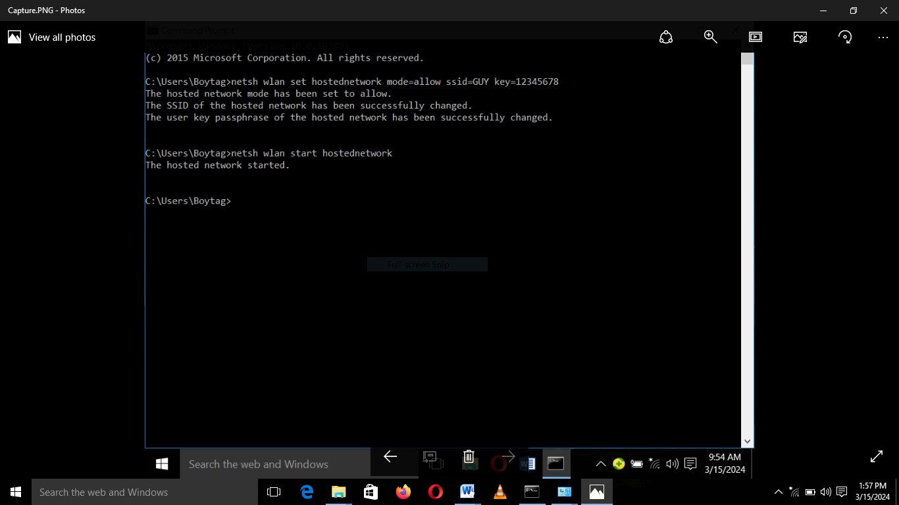

* We have to make sure our network discovery and our file and printers sharing is turned on in order to make files accessible. 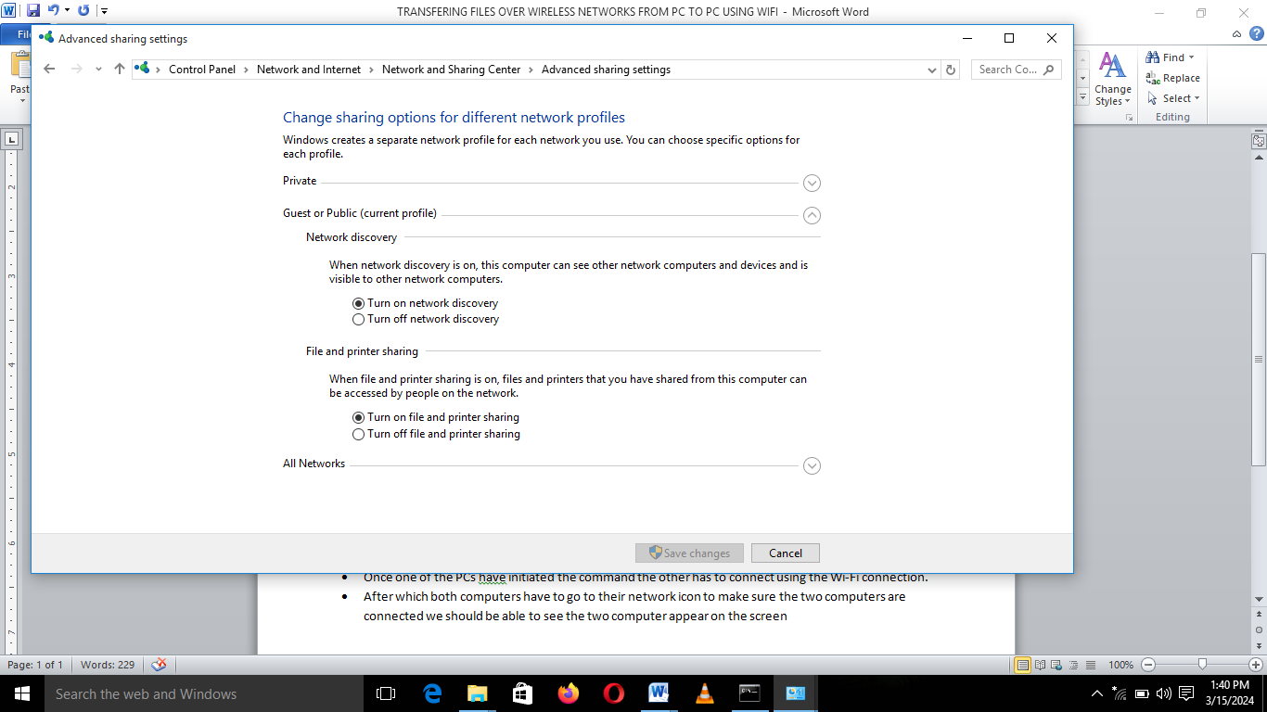
* Once one of the PCs has initiated the command the other has to connect using the Wi-Fi connection.
* After which both computers have to go to their network icon to make sure the two computers are connected we should be able to see the two computer appear on the screen.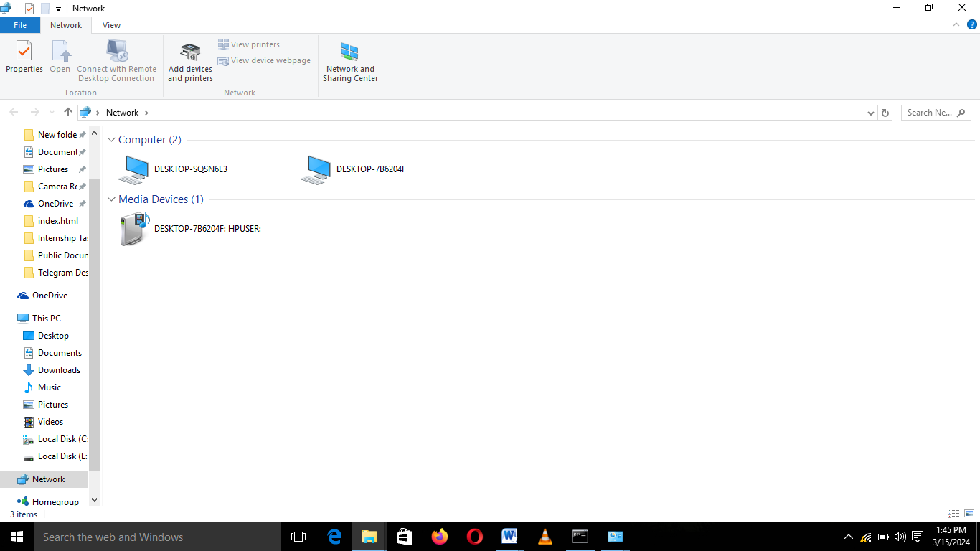

From here we can make files available and share.

* When we are done sharing files we can cut the connection by typing the command; ” netsh wlan stop hostednetwork”

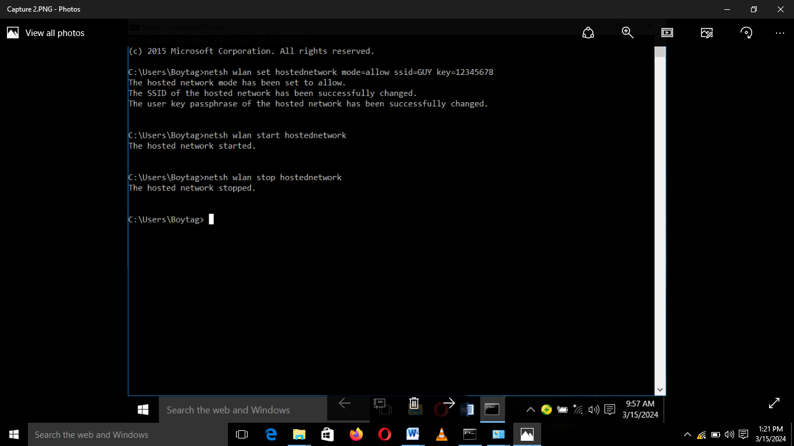

Part 2: Creating A Network With A Phone To A Host Machine.

Transferring files from a phone to a pc we need to use a Wi-Fi file transfer app which is a free to use app meaning it doesn’t need data to work.

When we have the app in our possession we can the start to set up the network.

* We need to start by configuring the Wi-Fi that is creating a Wi-Fi network available for the PC to connect to. Making sure to put a password so as to secure the network.

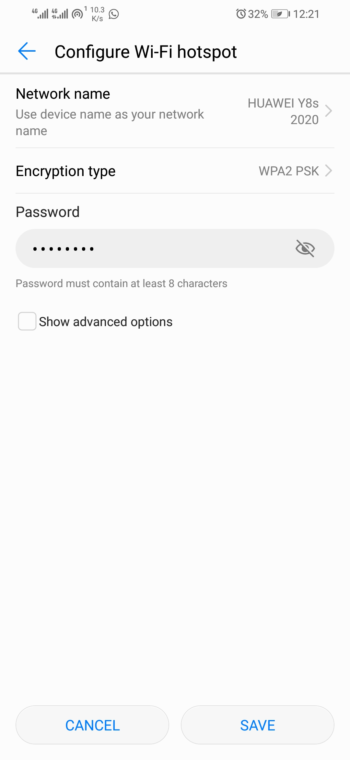

* From here we need to make sure the PC we want to connect to is connected to the Wi-Fi network we created by following the steps on the picture bellow. After which we open our browser and input the IP address given to us.

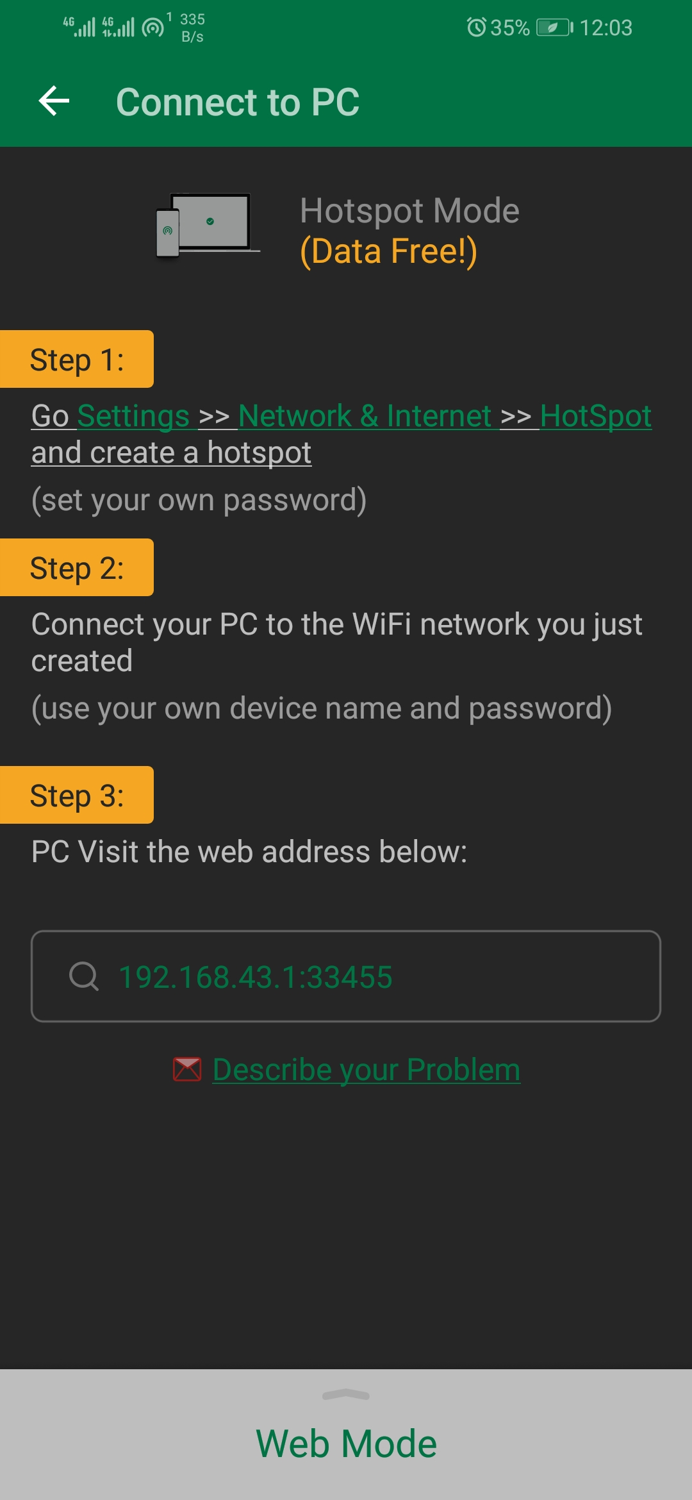

* 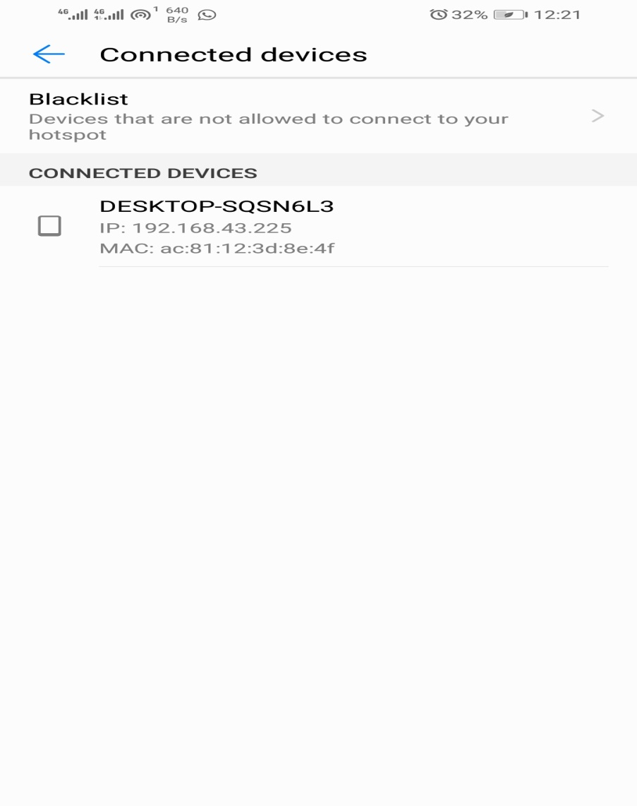On the side of the phone we connect to the PC we made available for connection.
* 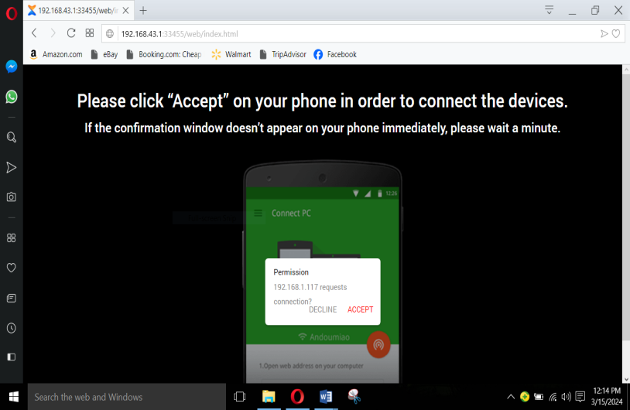 After the IP address has been searched a notification will pop on the screen of your phone tell you “a PC wants to connect” so we accept the demand making the connection complete.

*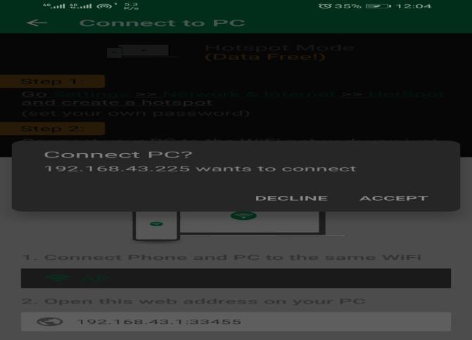*

When that is done the devices will be connected and we will be able to transfer files from the phone to pc and from pc to phone. This is how our PC screen will look like when it’s connected to the phone. 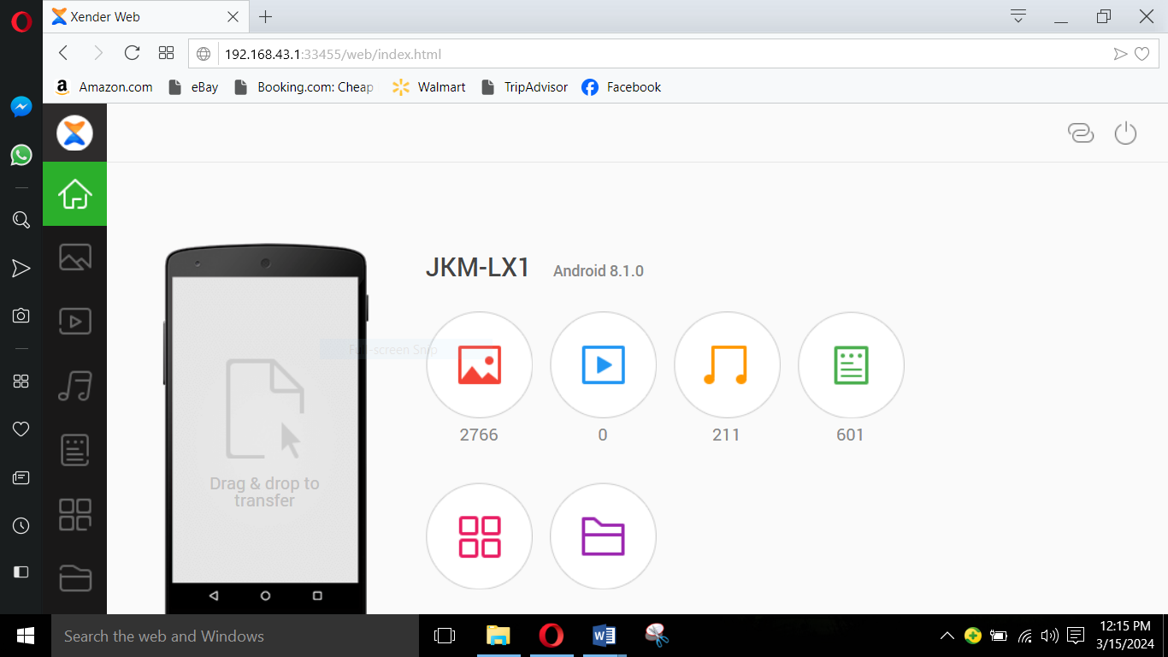

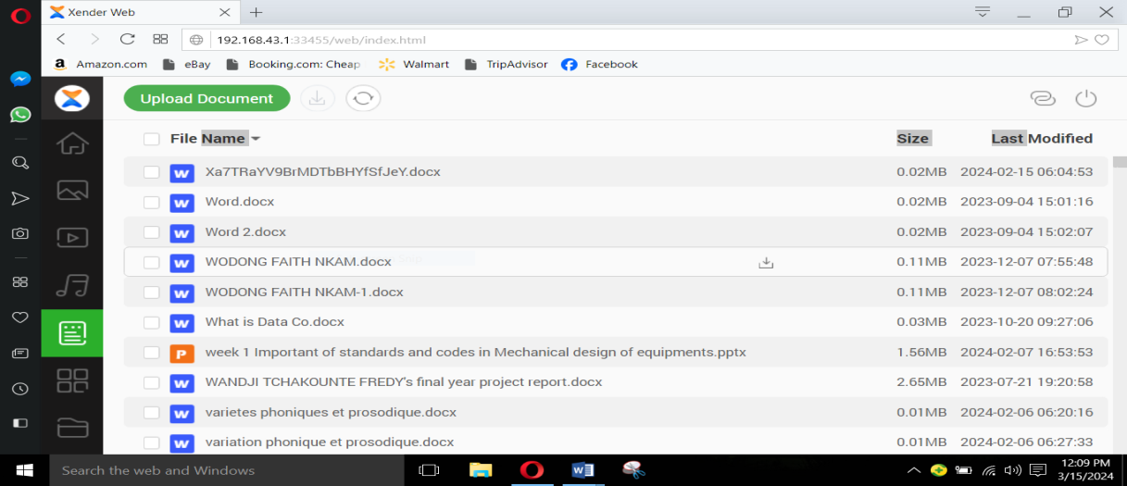We decided to transfer files using xender (an android app which is use in sharing files from one phone to another. It can also be used to share files between a phone and a pc.) since transfering the files through the file transfer was difficult. To transfer files we can either drag and drop or copy and paste the files.

When we are done transferring the files we can then decide to disenable/disconnect the network.

PART 3:Nearby Sharing.

We tried to connect our PCs using this method but since our PCs did not have this option we could not do the connection.